

|  |  |  |
| --- | --- | --- |
| Mathematics Department | |  |
| Course: A1MAA | |
| Topic Title: Applications of Rates & Percentages, Matrices & Matrix Arithmetic | |
| Test 1  Student Name:_____________________________________ | Date: ____________ | | |
| Special Instructions: **Calculator Allowed**, *,* | Time Allowed: 55 minutes | | |
| Formulae Sheet and 1 A4 page of notes allowed. | Marks: / 50 | | |
|  | | | |

**Question 1. (3 marks)**

In shop A, the marked price of a dining table is $840. The shop manager offers a 9.5% discount on cash sales.

In shop B, the same table is marked at $870 and a 12% discount is offered. Which shop **offers a better deal**? **Show** sufficient working to support your claim.

**Question 2. (2 marks)**

Assuming that the annual rate of inflation remains steady at 2.9%, what would the value of an item be in three years’ time if it costs $90.00 now?

**Question 3. (6 marks)**

Complete the following table:

|  |  |  |  |
| --- | --- | --- | --- |
| Cost of item | Selling Price | Profit / Loss? | What was the percentage profit or loss? |
| $450 | $510 |  |  |
| $1200 |  | Profit | 6% |
|  | $800 | Loss | 25% |

Show any necessary working below:

**Question 4. (2, 1, 1, 2: 6 marks)**

Tom’s annual salary was $82 000. This year he received a 5.5 % pay rise.

i) a) How much more money did Tom receive from the pay rise?

b) What was Tom’s new annual salary after the pay rise?

c) Determine Tom’s new weekly salary after the pay rise?

ii) Frank, Tom’s brother, runs a hardware store. To sell a lawn mower that he has had in the store for 2 years he decides to sell it at a % loss. Thomas sells the lawn mower for $262.50. What was the original price for the mower?

**Question 5. (1, 1, 3: 5 marks)**

An electronics store increased the prices of all laptops by 8%. A laptop originally cost $995.

1. What was the new price of the laptop after the price increase?

During the end of year sales, all stock was now discounted by 10%.

ii) What is the price of the laptop during the end of year sales?

iii) Calculate the overall **percentage change** in price from the original price.

**Question 6. (3, 4, 3: 10 marks)**

1. Find the value of x and y if

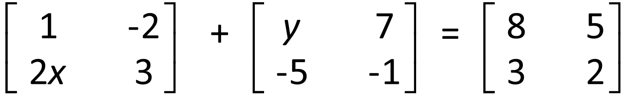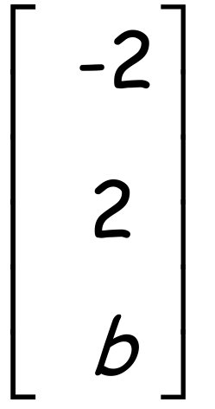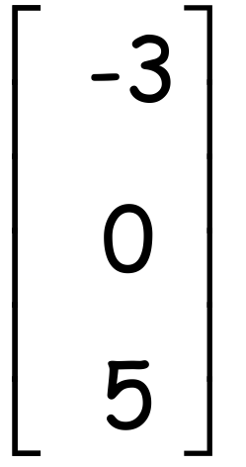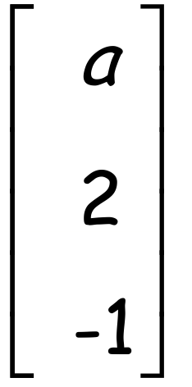

1. Find the values of a and b if **P** = **Q** = **R** = and **P + 2Q = R**
2. Find the values of m and nif

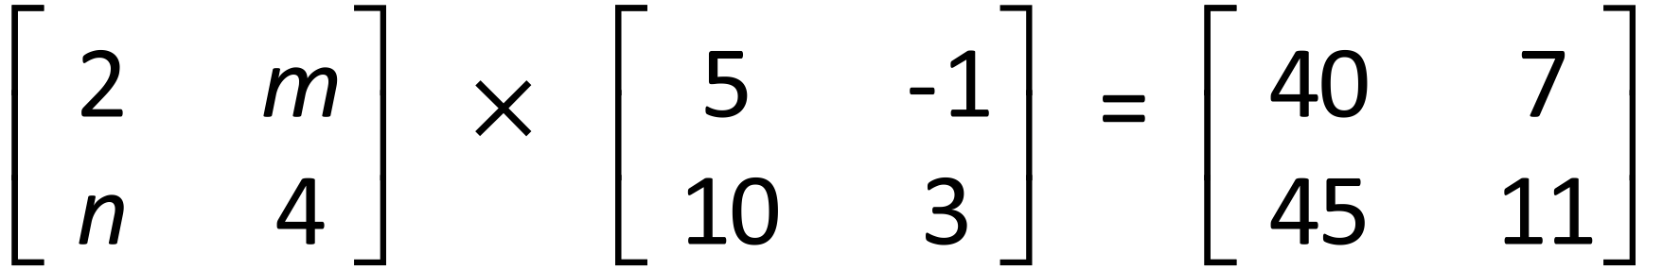

**Question 7. (2 ,1, 1, 1, 1, 3: 9 marks)**

a) Construct a one stage route matrix **R** for the following network showing Ben’s trip to school.

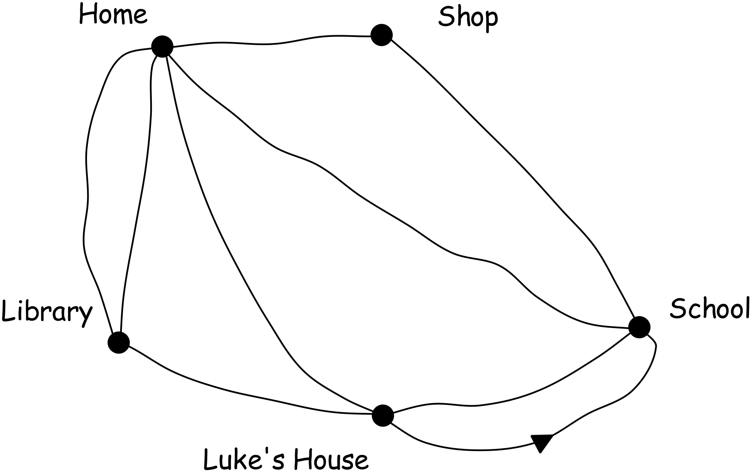

b) The two stage route matrix can be obtained by doing what to the original route matrix?

c) Give the two stage route matrix for Ben’s trip to school.

d) How many ways can Ben get to school if he makes one stop on the way?

e) How many ways can Ben get home from school if he makes one stop on the way?

f) On the way home from school today Ben needs to make two stops.

i) What needs to be done to matrix **R** to show these paths?

ii) Show this matrix

iii) How many ways can Ben get home if he stops at Luke’s house and the library?

**Question 8. (2, 3, 2, 2: 9 marks)**

Lucy has invented a new method for scoring points in the game of Tins. Each participant can score in

any of four ways (M, S, T & G) and their scores are added to form a grand total.

There are as follows:

* 10 points for a match (M)
* 7 points for a set (S)
* 3 points for a touch (T)
* 1 point for each game (G).

The number of matches, sets, touches and games for 5 different players (P1, P2, P3, P4, P5) are

provided in the matrix below.

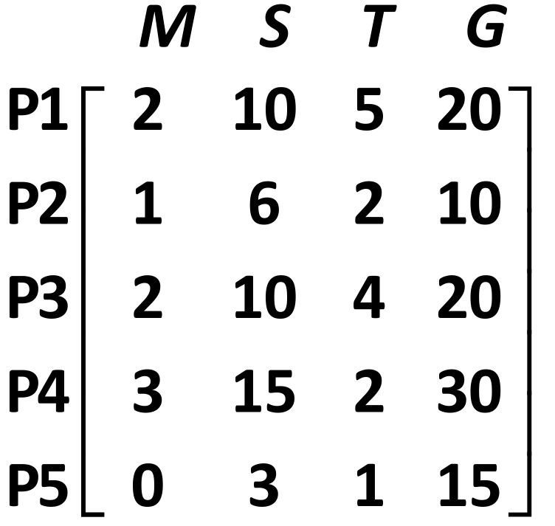

a) Write the **column matrix,** with rows representing in order M, S, T and G, that represents the

points for each way of scoring.

b) Show the matrix calculation needed to multiply the column matrix (from part a) by the matrix

provided for Question 8. Calculate this product.

c) What is the total score for P1? Where in the matrix from part b) is this score located?

d) Describe the data stored in the matrix generated in part b).

**Question 9. (1, 1, 1, 3: 6 marks)**

Three friends went on a trip overseas and brought back some unspent foreign currency which they

need to exchange back to Australian dollars (AUD).

They have made a table showing the amounts of each currency they each have.



The exchange rates when they convert their money are as follows:

10 000 IDR (Indonesian rupiah) = 0.9700 AUD

1 SGD (Singapore dollars) = 0.8666 AUD

1 HKD (Hong Kong dollars) = 0.1410 AUD

a) How much in Australian dollars (to the nearest ten cents) will Kate get for her Indonesian

rupiah (assuming she pays no commission fees)?

b) How much in Australian dollars (to the nearest ten cents) will Guy get for his Singapore dollars

(assuming he pays no commission fees)?

c) Using the same exchange rates as given in the table for Question 9, what is one Australian

dollar worth (to the nearest cent) in Singapore dollars?

d) Write a matrix operation to calculate the amount of Australian currency that each person will

receive when their foreign currencies (as shown in the table for Question 9) are converted.